Ayesha Fathima

Afathima20760@ucumberlands.edu

PROFESSOR.YING LIN.

**ETHICAL ISSUES IN**

**AI-HCI.**

**Identifying Ethical Challenges in AI/HCI Design**

**Introduction**

The integration of artificial intelligence (AI) into human-computer interaction (HCI) design brings numerous benefits but also significant ethical challenges. Identifying these ethical challenges is crucial to ensure that AI technologies are developed and deployed responsibly. This paper explores methods to identify ethical challenges related to AI/HCI design, using insights from four scholarly articles. Additionally, it presents an example of an ethical challenge observed in a non-AI context, providing a broader understanding of ethical considerations.

**Methods to Identify Ethical Challenges in AI/HCI Design**

**Literature Review**

A comprehensive literature review is a fundamental method to identify ethical challenges in AI/HCI design. This involves examining academic papers, books, and articles that discuss ethical issues in AI and HCI. Researchers can use databases such as Google Scholar, JSTOR, and IEEE Xplore to find relevant literature. Keywords like "ethical AI," "HCI ethical issues," and "AI ethics" can help locate pertinent sources.

For instance, a search on Google Scholar for "ethical challenges in AI design" yields numerous articles that highlight issues such as bias, privacy, and accountability. Reviewing these articles provides a solid foundation for understanding common ethical concerns in AI/HCI design.

**Case Studies Analysis**

Analyzing specific case studies is another effective method to identify ethical challenges. Case studies provide real-world examples of ethical dilemmas encountered in AI/HCI projects. Researchers can find case studies in academic journals and online repositories. By examining the challenges faced and the solutions implemented, researchers can gain insights into practical ethical issues and remediation strategies.

For example, the Facebook-Cambridge Analytica data scandal is a well-documented case study that illustrates significant ethical issues related to data privacy and misuse of personal information.

**Expert Interviews**

Conducting interviews with experts in AI ethics and HCI is a valuable method to identify ethical challenges. Experts can provide firsthand insights into the ethical issues they encounter in their work and suggest potential solutions. Video conferencing tools like Zoom or Skype can be used to conduct these interviews.

During interviews, questions can focus on the most pressing ethical issues in AI, how to mitigate ethical risks, and the role of ethics in HCI design. The insights gathered from these interviews can enrich the understanding of ethical challenges and inform best practices.

**Ethics Frameworks and Guidelines**

Reviewing existing ethics frameworks and guidelines is crucial for identifying ethical challenges in AI/HCI design. Organizations like IEEE and ACM provide comprehensive guidelines on ethical AI development. Government publications also offer valuable insights into regulatory and ethical standards.

For instance, the IEEE Global Initiative on Ethics of Autonomous and Intelligent Systems outlines principles and recommendations for ethical AI development, covering aspects such as transparency, accountability, and fairness. Reviewing these guidelines helps identify potential ethical issues and establish best practices for AI/HCI design.

**Workshops and Conferences**

Attending workshops and conferences focused on AI ethics and HCI is an excellent way to stay informed about current ethical challenges and solutions. These events bring together researchers, practitioners, and policymakers to discuss and address ethical issues in AI and HCI.

For example, the AAAI/ACM Conference on AI, Ethics, and Society and the CHI Conference on Human Factors in Computing Systems are prominent events where ethical challenges are discussed. Participating in these events provides opportunities to learn from experts, network with peers, and stay updated on the latest developments in AI ethics.

**Example of an Ethical Challenge**

**Workplace Surveillance**

In a previous job, I observed an ethical challenge related to workplace surveillance. The company implemented software to monitor employees' computer activities, including keystrokes, websites visited, and time spent on tasks. While the intention was to boost productivity and ensure compliance, it raised significant ethical concerns.

**Ethical Issues:**

1. **Privacy Concerns:** Employees felt their privacy was invaded as every action on their computers was monitored.
2. **Trust Erosion:** The surveillance led to a decrease in trust between employees and management, creating a hostile work environment.
3. **Stress and Anxiety:** Constant monitoring increased stress and anxiety among employees, affecting their mental health and overall productivity.

**Outcome:** After several complaints and a decline in employee morale, the company scaled back the surveillance measures. They adopted a more balanced approach, focusing on clear communication and setting performance expectations without invasive monitoring.

**Conclusion**

Identifying ethical challenges in AI/HCI design requires a multi-faceted approach, including literature reviews, case studies, expert interviews, ethics frameworks, and participation in workshops and conferences. These methods provide a comprehensive understanding of ethical issues and inform best practices for responsible AI development. By addressing these challenges proactively, we can ensure that AI technologies are developed and deployed in a manner that respects ethical principles and promotes social good.

*Figure-1*

*Figure-2*

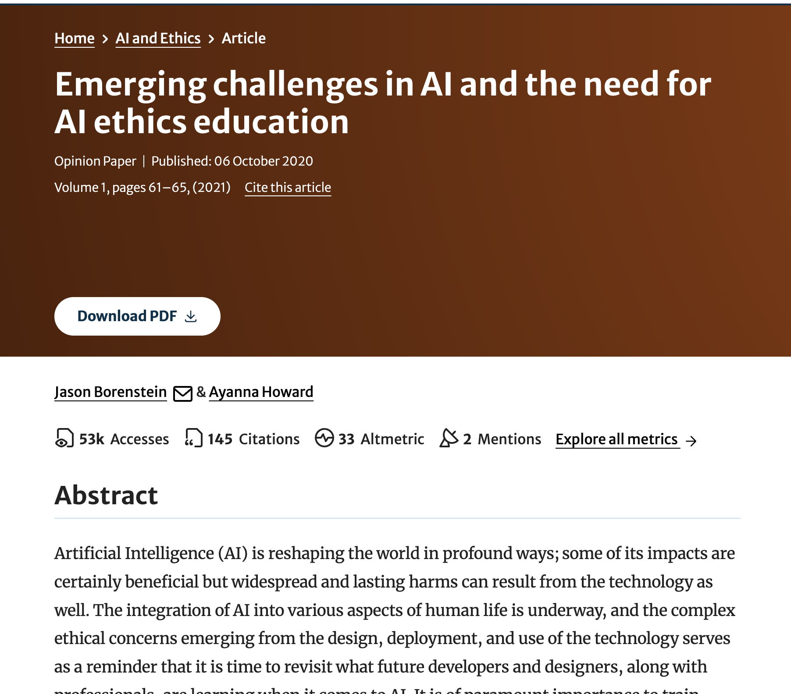

*Figure-3*

*Figure-4*

**REFERENCES**

Ricardo Baeza-Yates. 2022. Ethical Challenges in AI. In Proceedings of the Fifteenth ACM International Conference on Web Search and Data Mining (WSDM '22). Association for Computing Machinery, New York, NY, USA, 1–2. <https://doi.org/10.1145/3488560.3498370>

Ewen McAlpine, Pamela Michelow, Eric Liebenberg, Turgay Celik, Are synthetic cytology images ready for prime time? A comparative assessment of real and synthetic urine cytology images, Journal of the American Society of Cytopathology, 10.1016/j.jasc.2022.10.001, **12**, 2, (126-135), (2023).

Robert Rasmussen, Thomas Sanford, Anil V. Parwani, Ivan Pedrosa, Artificial Intelligence in Kidney Cancer, American Society of Clinical Oncology Educational Book, 10.1200/EDBK_350862, 42, (300-310), (2022).

Leikas, J. (2019) The ethics of AI – what are we even talking about? <https://vttblog.com/2019/01/16/the-ethics-of-ai-what-are-we-even-talking-about/>

Müller, V. (Ed.). (2016) Risks of Artificial Intelligence. CRC Press, Taylor & Francis Group.